**SUPPLIER DATABASE OUTPUTS**

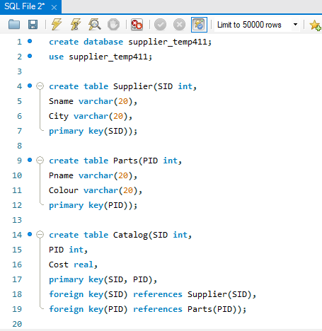

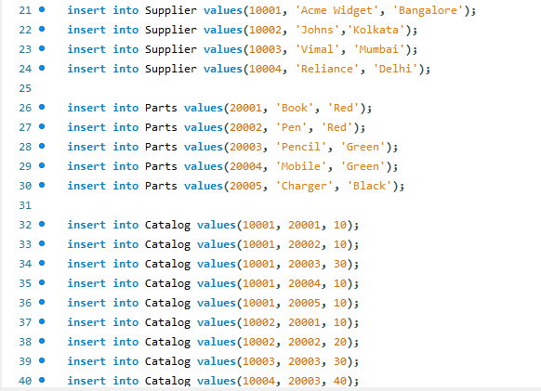

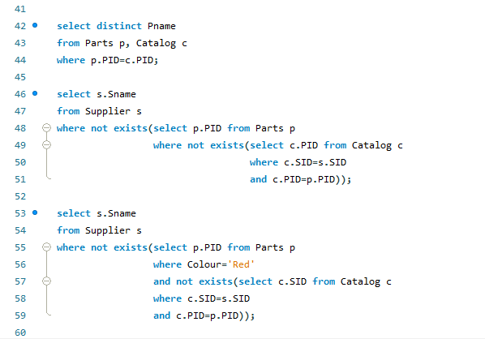

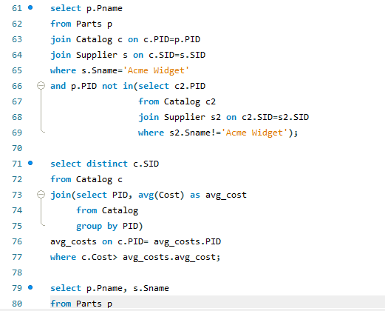

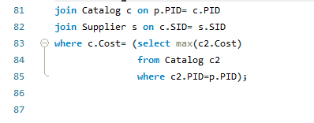

Outputs:

select distinct Pname

from Parts p, Catalog c

where p.PID=c.PID;



select s.Sname

from Supplier s

where not exists(select p.PID from Parts p

where not exists(select c.PID from Catalog c

where c.SID=s.SID

and c.PID=p.PID));



select s.Sname

from Supplier s

where not exists(select p.PID from Parts p

where Colour='Red'

and not exists(select c.SID from Catalog c

where c.SID=s.SID

and c.PID=p.PID));



select p.Pname

from Parts p

join Catalog c on c.PID=p.PID

join Supplier s on c.SID=s.SID

where s.Sname='Acme Widget'

and p.PID not in(select c2.PID

from Catalog c2

join Supplier s2 on c2.SID=s2.SID

where s2.Sname!='Acme Widget');

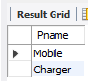

select distinct c.SID

from Catalog c

join(select PID, avg(Cost) as avg_cost

from Catalog

group by PID)

avg_costs on c.PID= avg_costs.PID

where c.Cost> avg_costs.avg_cost;

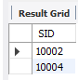

select p.Pname, s.Sname

from Parts p

join Catalog c on p.PID= c.PID

join Supplier s on c.SID= s.SID

where c.Cost= (select max(c2.Cost)

from Catalog c2

where c2.PID=p.PID);

